Managing and Adapting Practice (MAP): Evidence-Based Practices in OMH-Licensed Community Based Provider Agencies to Serve Children
with Significant Mental Health Needs and Their Families
April 2024

The New York State (NYS) Office of Mental Health (OMH) is providing one-time funding totaling to OMH-licensed, designated or funded programs to improve implementation and sustainability of evidence-based care specifically through the Managing and Adapting Practice (MAP) model.

Evidence-Based Practices Investment:
Participating agencies are eligible for a one-time reimbursement of a minimum of $10,000 per group of two clinicians and one clinical supervisor attending the full (4-day) MAP training and completing the required follow-up tasks. Agencies must send a minimum cohort of three staff in order to be eligible for funding. If an agency already has one or more trained supervisor(s) in place, they may also apply to send a group of three (3) clinicians, with the assurance they will be supervised by a MAP certified supervisor.

Agencies can register for training of at least three staff (or demonstrate they meet the criteria for the other options outlined above) and submit a formal attestation, they commit to use funds to pay for: certification costs, paid time to allow staff to attend trainings during work hours, and/or staff time to work on implementing MAP with clients (including utilizing MAP resources before, during and after sessions).

Funding Requirements:
Staff recommended for attending MAP training must:
- Commit to the training program for 4-5 months
- Provide direct clinical services
- Carry a caseload that includes at least 3 children or adolescents
- Frequently treat childhood anxiety, depression, trauma, and/or disruptive behavior disorder
OR supervise clinicians who meet the above criteria (These clinicians must also be participating in MAP training)

Full commitment to the MAP training includes:
- Participation in a 1-hour pre-training webinar and 4 days of webinar-based training
- Participation in at least 6 of 8 webinar consultations (bi-weekly by video conference) across 4 months
- Participation in a 4-hour mid-point webinar training (held 2 months after the initial 4-day training)
- Submission of certification materials at the end of the 5-month period with a passing score to qualify for certification
- All three individuals complete trainings and receive receipt of NYS MAP certification
- Integration and continued use of MAP for a minimum of 6 months post certification
- All three individuals participate in training feedback and attendance at no more than 2 one-hour sessions with OMH regarding the promotion and applications of MAP more widely in NYS
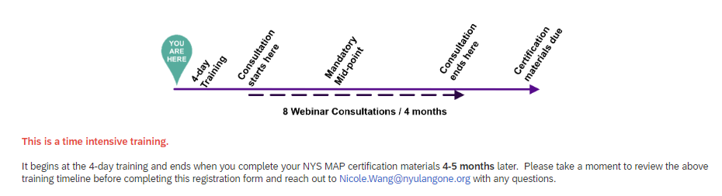
Additional Staff allowances:
Please indicate which staffing configuration that will be attending (check all that apply):
- Three-person cohort: supervisor and two clinicians
- Three clinician cohort (verification of certified MAP supervisor required)

To participate in this funding, entities will be required to:
- Participants submit attestation indicating understanding of all required components of participation.

